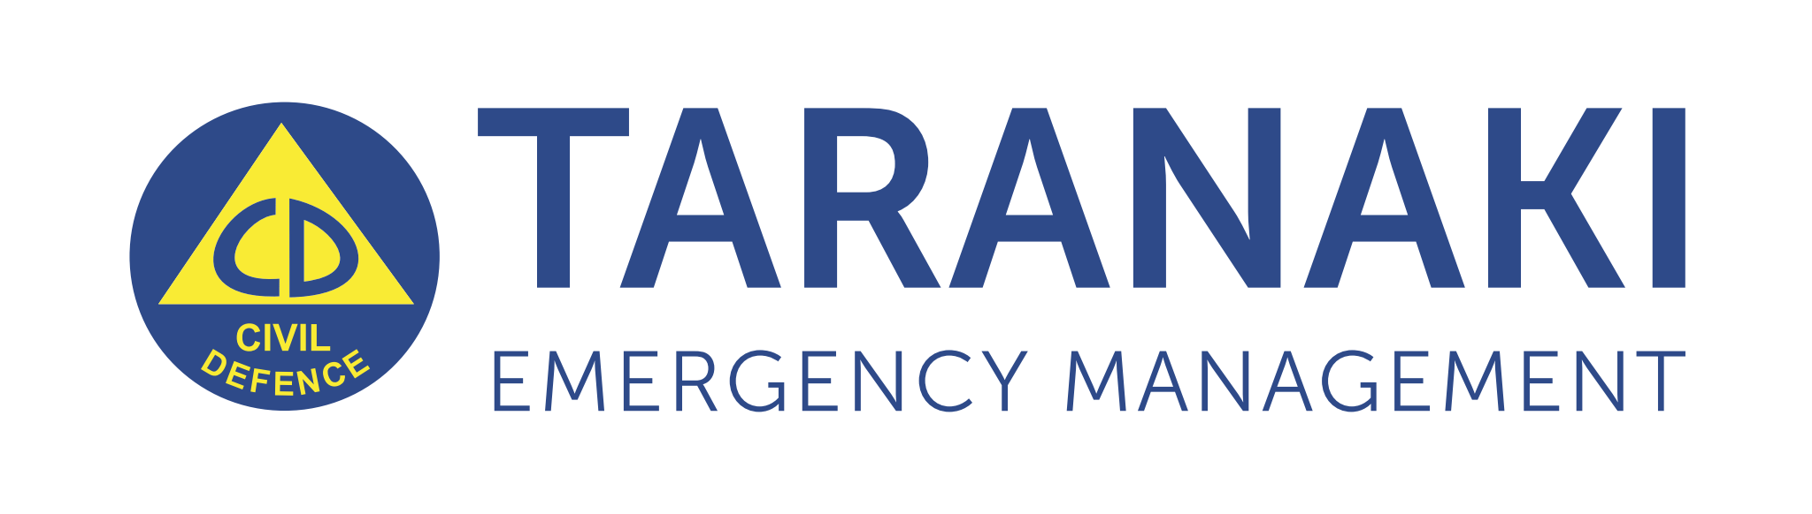
MEDIA RELEASE 1
IMMEDIATE RELEASE
19 August 2022, 11:30am

Civil Defence responds to severe weather event
Taranaki’s Civil Defence Emergency Co-ordination Centre (ECC) and the New Plymouth Emergency Operation Centre (EOC) have activated in response to the severe weather event that is hitting the region.
More than a metre of rain has fallen on Mount Taranaki causing significant flows down all rivers resulting in several families voluntarily evacuating their homes. Flooding, road closures, dangerous driving conditions, animal welfare concerns, and fallen trees are still an issue.
Taranaki Civil Defence Emergency Management (CDEM) Controller Todd Velvin says if people feel unsafe or see water rising rapidly, they should be proactive and move to higher ground.
“Don’t wait for official warnings, if you see water rising, leave and don’t return until it is safe to do so. Be prepared with a grab bag packed with clothing, medication, and essential supplies for each family member.
People should also make plans for their pets and shift stock from low lying areas to higher ground.”
Taranaki Regional Council has been monitoring river levels around the region overnight and will continue to do so today.
Daniel Harrison director-operations Taranaki Regional Councils says: “Taranaki Regional Council has been monitoring river levels around the region overnight and will continue to do so today.
“Council staff are stationed at the Waitara Flood Protection Scheme and monitoring is ongoing. At this stage, there are no plans to implement further flood protection measures and the Waitara Bridge is expected to remain open. However, monitoring is ongoing and if the situation changes, we will provide an update to the community.”
Police are urging motorists to take care on the roads with bad weather causing several issues across Taranaki. These include motorists hitting potholes due to a lack of visibility and surface flooding.
Taking care means: increasing your following distance; it takes longer to stop in the rain; driving to the conditions; delaying unnecessary travel if possible; putting your headlights on; slow down, and be patient.
Civil Defence is advising people to never drive through flood water. Most deaths during flood events are a result of cars being swept away by flood water and people becoming trapped.
“Even 30 centimetres of water can sweep your car away. If you come across flood waters turn around and go another way. If your car stalls abandon it immediately and head to higher ground.”
The Metservice forecast for Taranaki overnight and into tomorrow is for more heavy rain easing overnight and the wind watch has been lifted, but an additional short burst of heavy rain is expected tomorrow morning.
“We will continue to closely monitor and respond to the developing situation with our partner agencies. We are in a state of preparedness and will respond accordingly. “
Civil Defence is urging people to be prepared and have a plan and leave early if water starts to rise.
If life or property is in danger phone 111.
#ENDS
474 words

Reporters for more information please contact:
Taranaki Civil Defence Emergency Management
ECC Public Information Manager
lisa.gregory@cdemtaranaki.govt.nz
0272485571

